We hold these truths to be self-evident, that all men are created equal, that they are endowed by their Creator with certain unalienable Rights that among these are Life, Liberty and the pursuit of Happiness. —

Hello, my named is Maury Johnson and I live in Monroe County WV. My home and family farm is in the path of the Mountain Valley Pipeline—MVP. My home is approximately 800 ft from this threat to my LIFE—my LIBERTY and my pursuit of HAPPINESS…. as put forth by second paragraph of The Declaration of Independence that I just read.
In October of 2014 I first heard about the MVP when at a community picnic a neighbor asked me if I had gotten a letter about a pipeline that a corporation wanted to locate across the area. I had not heard anything about this until a few days later, when I got MY LETTER… This is when my entire life started to descend into chaos.
Little did I know that not only would they (the pipeline developers) seek permission to locate the pipeline across my property, but if I objected, they would use the “power granted to them by a corrupt government” to force me to let them put a ticking time bomb aka the MVP across the property. That nothing I could do would allow me to object to the environmental destruction, including the almost certain destruction to the water resources on my property or the region in general. The stress and sheer terror of living with the fact that my life and the lives of my friends, neighbors and other citizens would be put at constant risk if this project was allowed to progress to fruition, with the assistance of the very government agencies that are suppose to protect the “general welfare of its citizens”
Unfortunately, no government or government agency has been concerned with any of those private citizens who are in the path of either the MVP or the Atlantic Coast Pipeline or ACP.
My family lands have been a part of my family heritage for over 150 years. To me and many in my family, the land is as important as a family member. 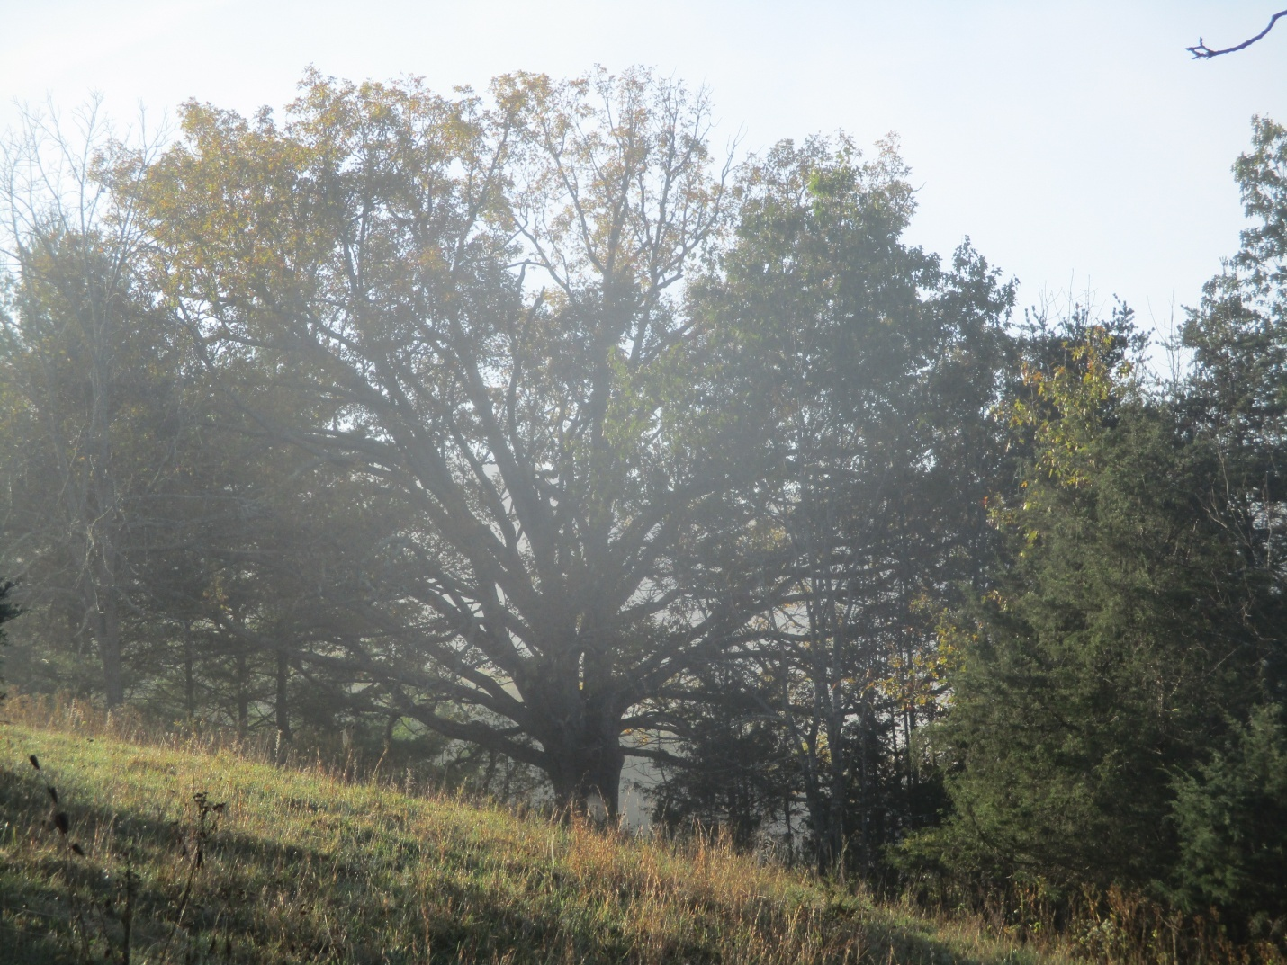
I also live in the shadow of the majestic Peters Mountain. This mountain influences everything that happens in my area. It influences the weather, our views of nature. It is possibly the greatest single supplier of fresh, “world class” water in the United States. The MVP threatens these Water Resources as well as the outstanding beauty and other resources provided by this Mountain.
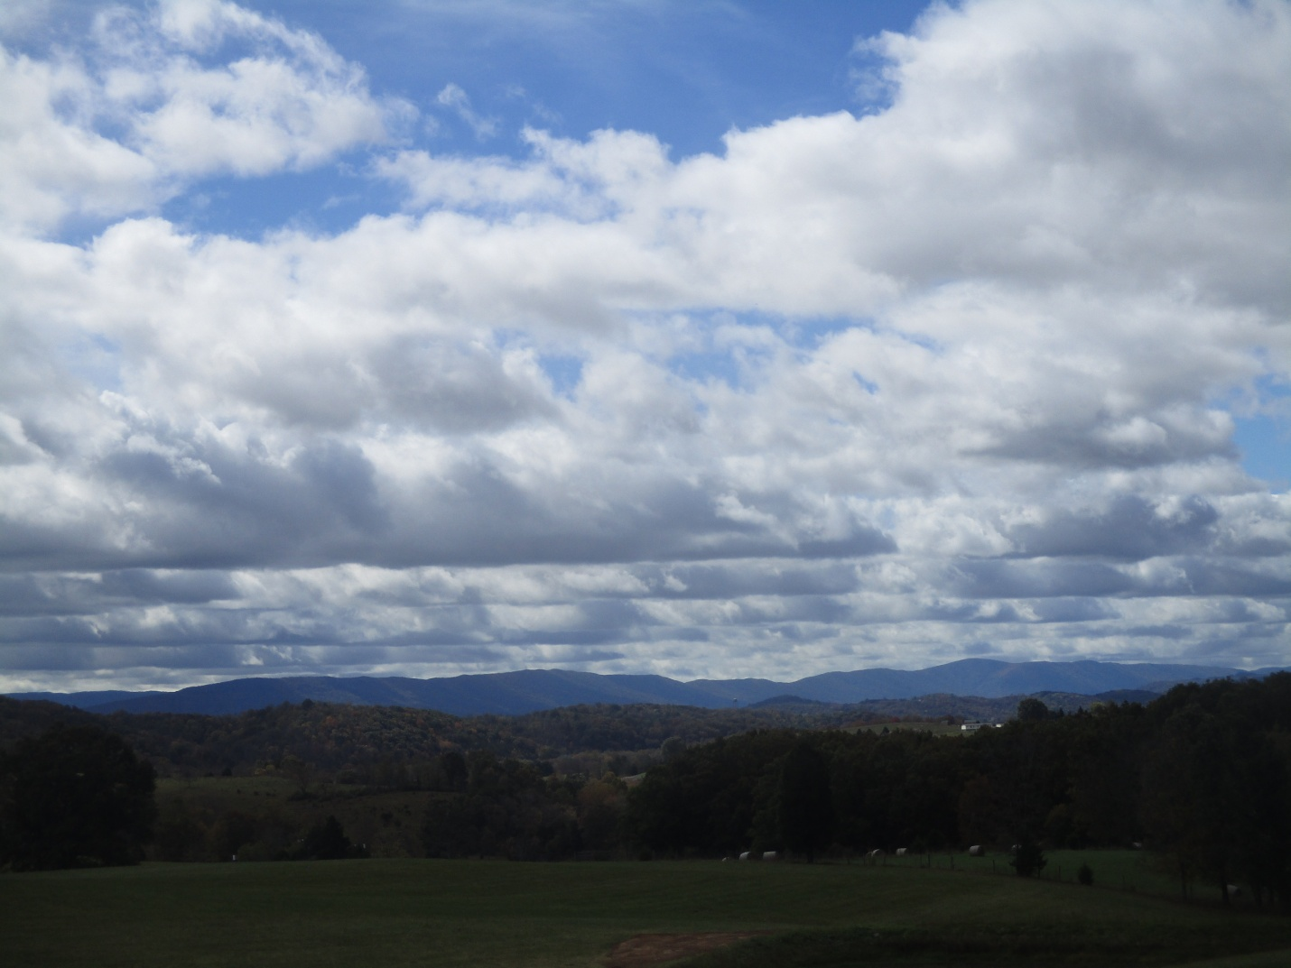
Peters Mountain also hosts a short section of The Appalachian Trail. A section that was deliberately incorporated into the trail by the original trail designers to allow visitors to witness the incredible view across Southern WV ( Monroe, Summers, Greenbrier, Mercer and Raleigh Counties in WV. )
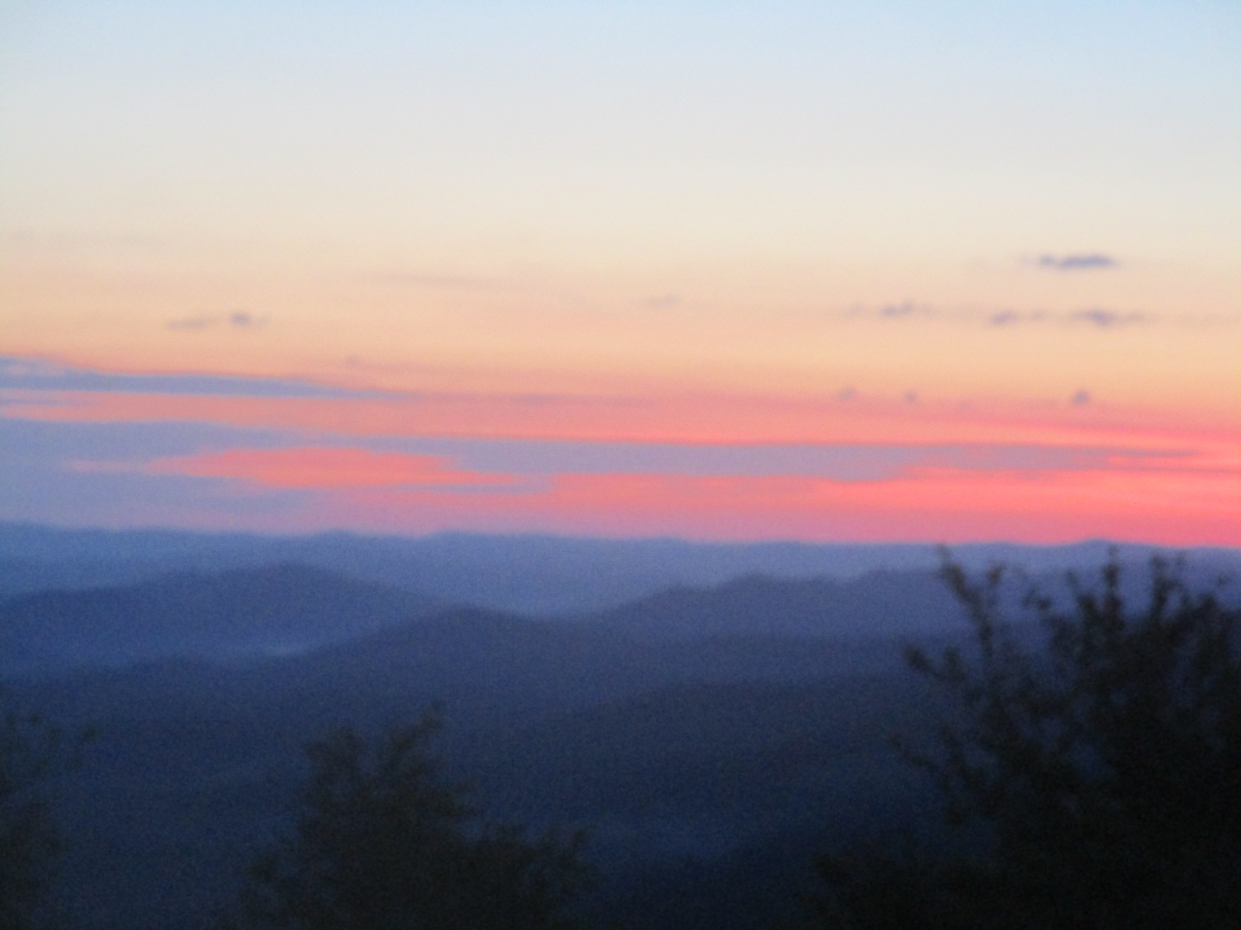
This “detour” made by the trail designers including the countless hours of work made by the trail builders and trail maintainers (of which I am one) would be destroyed or at the very least be greatly compromised by the MVP. This project is so destructive to the AT that in an editorial published in the Roanoke Times and in the Monroe Watchman newspapers, Andrew Downs the Virginia Regional Director for the Appalachian Trail Conservancy (ATC) stated: “The Appalachian Trail Conservancy strongly objects to MVP’s proposed route. The ATC’s mission is to ensure the Appalachian Trail and the scenic landscape that surrounds it is preserved and protected for generations to come. More than one-third of all Americans are within a day’s drive of the magnificent Appalachian range which draws all types of visitors – picnickers, campers, hunters and hikers – and contributes to the economic health of local rural communities…
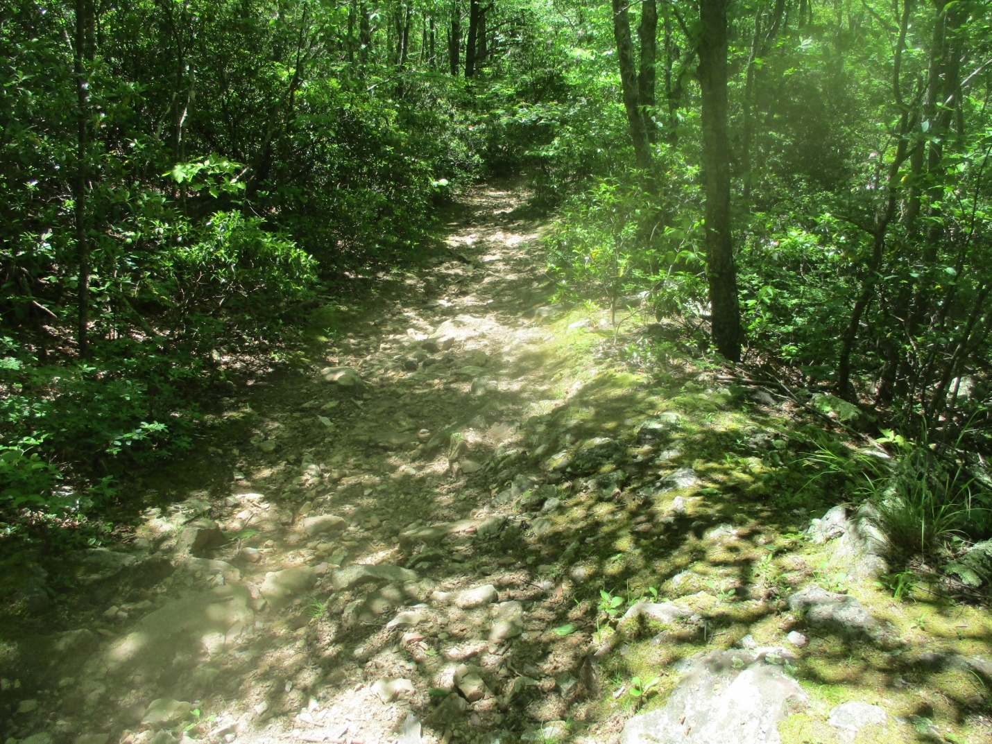
The ATC finds that MVP’s proposed routing could not be worse. The route snakes through the Appalachians requiring thousands of acres of forest to be cleared and creating gashes the width of a 12-lane highway. The resulting eyesores would be devastating to the trail and surrounding landscape, and would be seen from as far as 20 miles away.”
In an earlier letter sent to FERC in November of 2016, he stated on behalf of the ATC that, “Our own analysis concurs with the statements of the United States Forest Service( USFS) and suggests that the proposed Mountain Valley project represents a serious threat to the scenic value of the A.T. well beyond the scope of similar projects - as many as 19 prominent AT vistas may be severely impacted from this project, many of them viewing impacts as they occur on USFS land. “
The cumulative impacts to the AT would cover nearly 100 miles. “The issue of cumulative impacts is especially important to the AT given the nature of long distance hiking.”
The MVP project is therefore committing basic human rights crime against every citizen of the world that visits or plans to visit the trail or relies on the trail for business, tourism or other human needs. It also threatens every trail across the US, if it is allowed to progress as proposed. The same is true of the two Wilderness Areas, the Peters Mountain and Brush Mountain Wilderness, to the Old Growth Forest in the JNF (Jefferson National Forest) as well as to the IRA (Inventoried Roadless Areas) within the JNF (Jefferson National Forest) that will be destroyed and/or compromised. These are just a few examples of the Crimes Against Nature that this pipeline would wreck on the citizens of the area, the US and the World.
In reference to Environmental & Public Health I believe that our very health and lives are threatened by leaking methane, destroyed and polluted water resources, our diminished sense of security in our homes along the corridor, and the other environmental and public health problems brought about by these pipelines and the industrialization of what were once pristine rural areas.
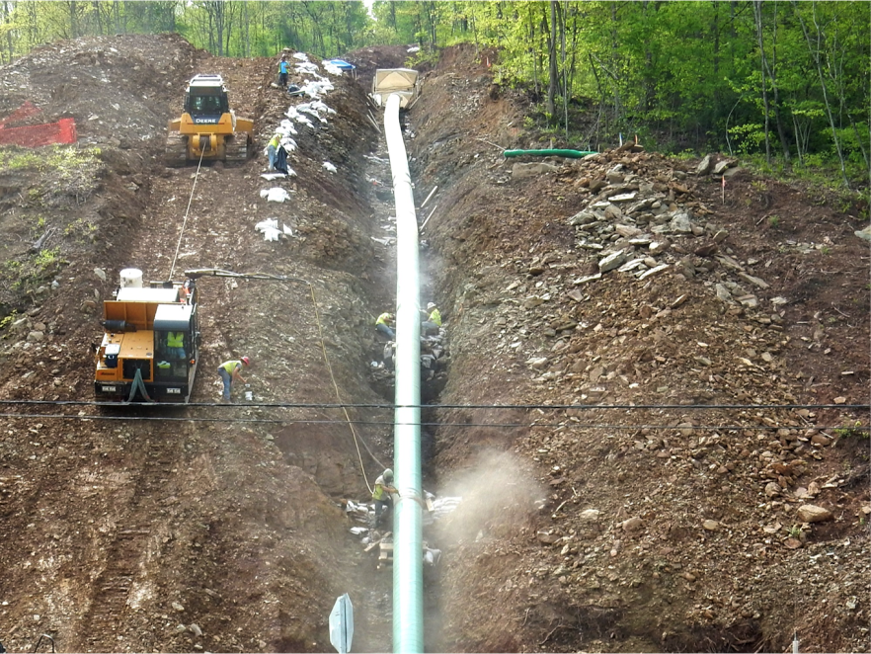
(Picture by Bill Hughes- Ohio Valley Environment Coalition – 2016)

I live in the Giles County Seismic Zone, I have been aware of this zone since I first studied it while a Science Major at Concord College (University) in the late 70’s and early 80’s.

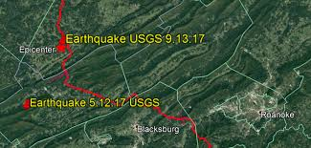
Location of two Earthquakes that have occurred in the Giles County Seismic Zone in 2017 in relationship to the MVP

Although much had been written about this seismic or earthquake zone since the USGS Study of the area was released in 1983. It does not take a “rocket scientist” to know that these types of projects, large diameter high pressure pipelines, nuclear reactors, large dams and the like should not be built in this zone.
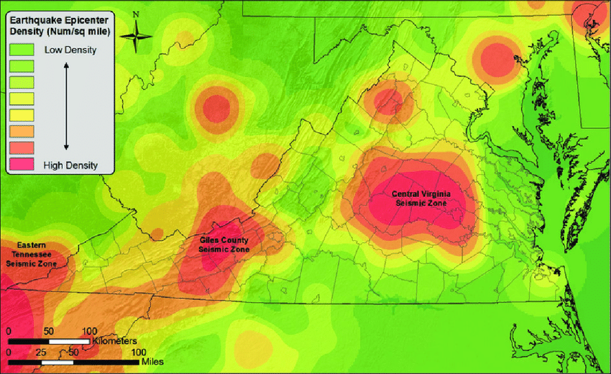

Coupled with the fact that the MVP would travel though some of the heaviest concentration of unstable karst topography in the Eastern US if not in the entire USA in the counties of Monroe and Summers in WV and Giles, Craig and Montgomery counties in VA should make this a no build area. 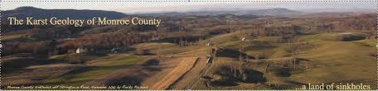
(Photo courtesy of Indian Creek Watershed Association by Rocky Parsons)

If that is not enough reason to not build this pipeline, consider that the highly unstable soils, prone to landslides and extremely steep slopes through the border area of Va and WV from Fayette County WV to Franklin County Va should be the “Three Strikes” needed not to build or approve this project. 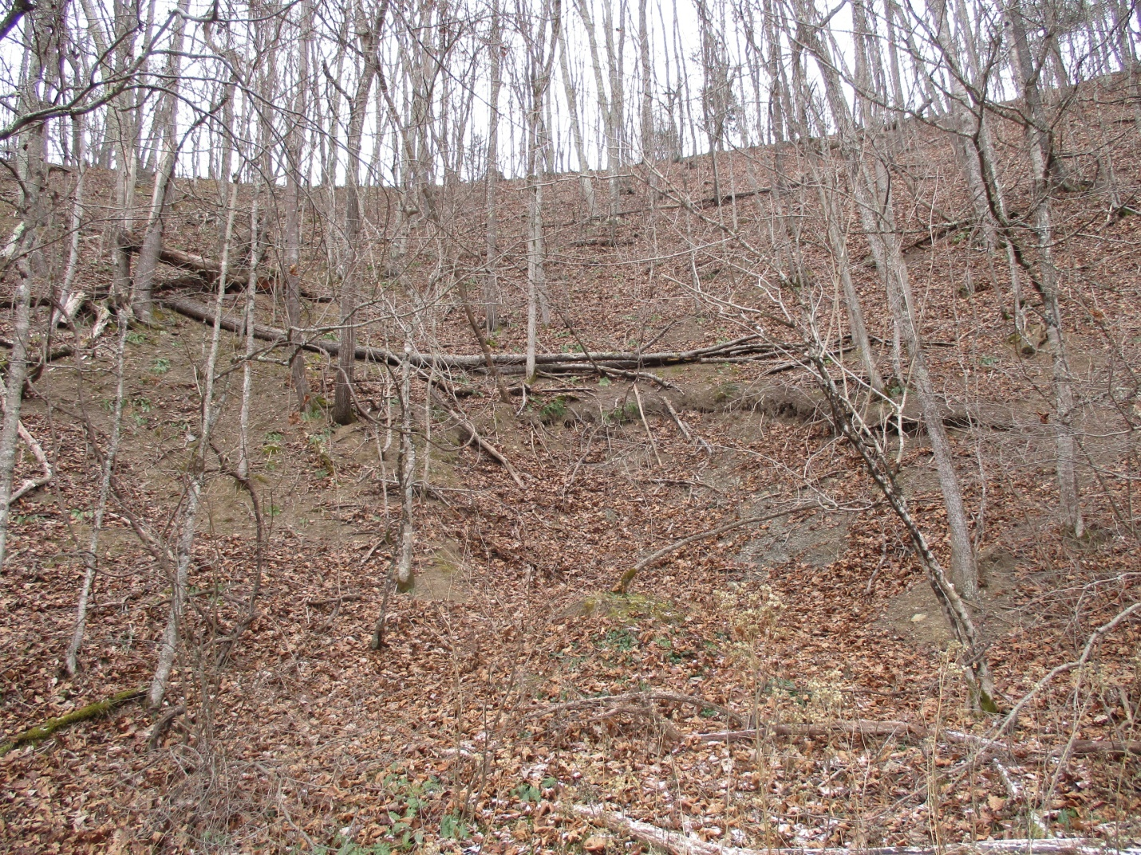
(Landslide on my farm, near the MVP corridor that occurred in 2009 after a heavy rain)

But Corporate Greed has so far prevailed in this pipeline project approval. I would like to quote longtime FERC Commissioner and Former FERC Chairman Cheryl La Fleur, when on October 13th, 2017 she filed this objection to the MVP and the ACP “Given the environmental impacts and possible superior alternatives, approving these two pipeline projects (the MVP and the ACP) on this record is not a decision I can support. For these reasons, I respectfully dissent.”

As mentioned earlier, our very heritage is being threatened by the MVP as it treks across what has been an unspoiled landscape. Places like Newport in Giles County Va, the Greenbrier River in Summers County WV, 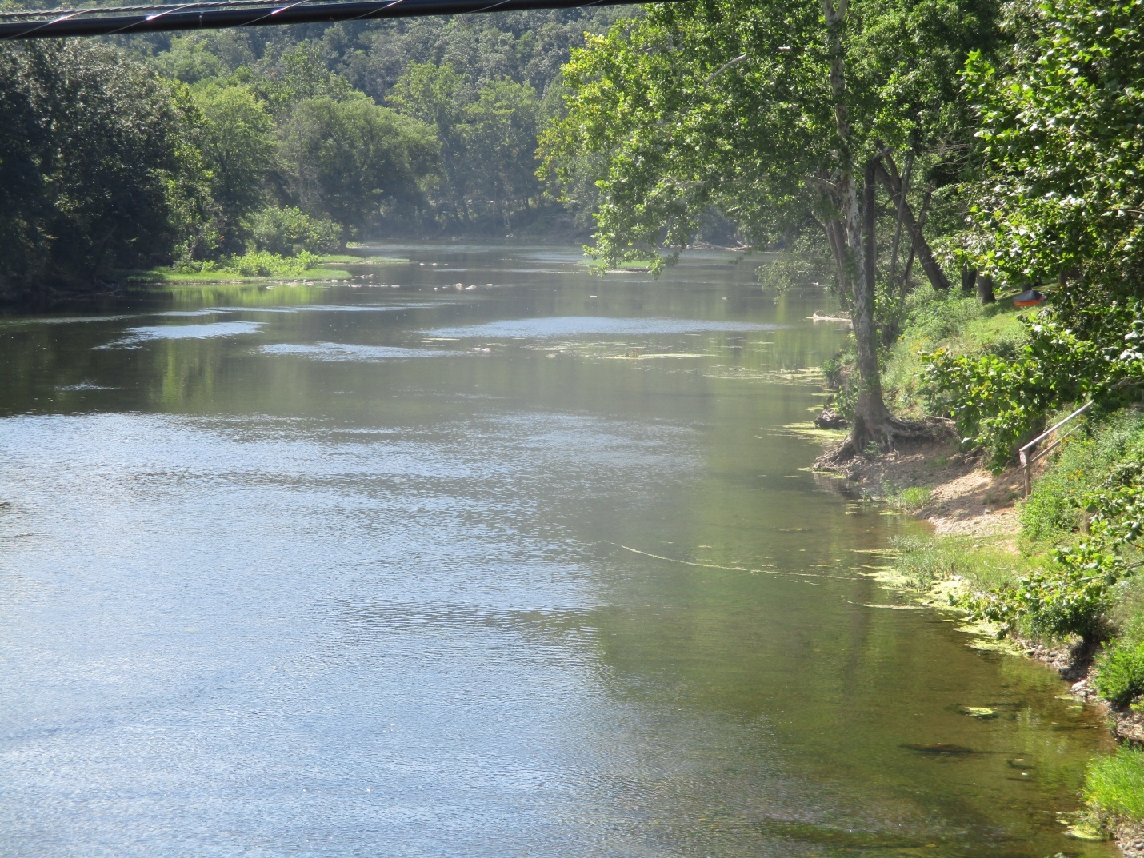
(Proposed Crossing of the MVP on the Greenbrier River)

The Narrows of Hans Creek, Ellison’s Ridge and Peters Mountain in Monroe County WV are unique cultural resources that cannot be replaced. They are among the last unspoiled places to be found in our area. Many people including myself consider these places to be spiritual in many ways and a symbol of our heritage. The MVP will destroy these and other such areas in pursuit of “private profits”.
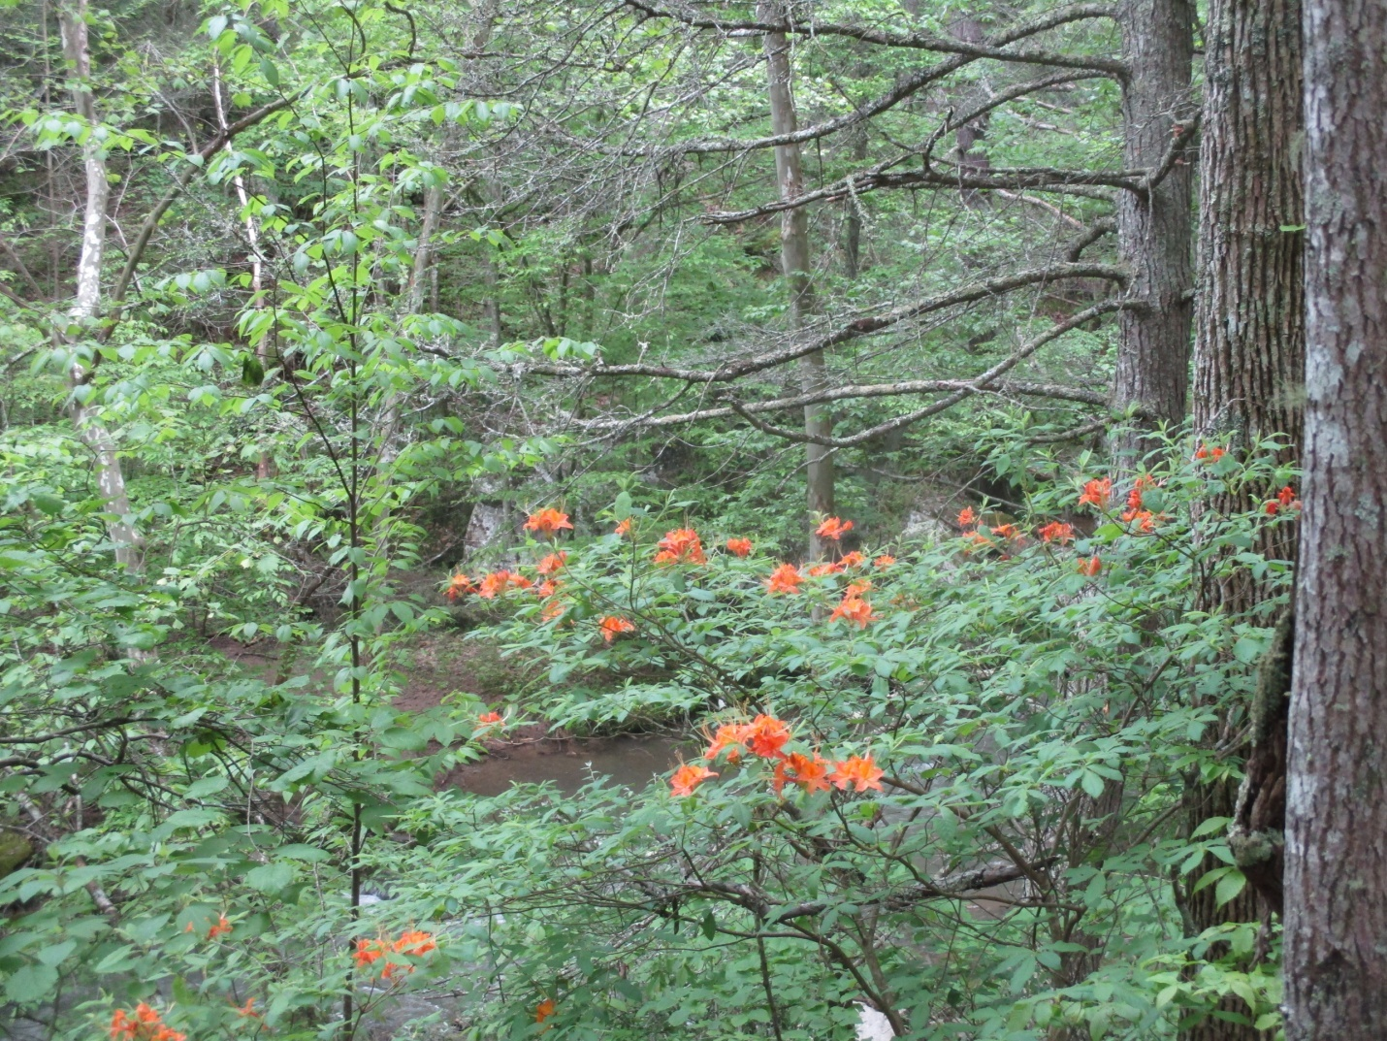
Orange Azaleas in the “Narrows of Hans Creek”

I see much lacking in the Regulatory & Permitting rules and procedures with projects such as the MVP. It has been my experience that much of the rules are stacked against citizens who chose to oppose the “Corporate Giants” who propose such projects. Failures by the very agencies that are suppose to protect our environment; our safety and welfare are disheartening.

The Erosion & Sediment Control and impacts to wetlands and water body crossings such as those crossing Hans Creek, Indian Creek and the iconic Greenbrier and Gauley Rivers in WV are issues that should be taken more seriously by those who are charged by our citizens to enforce such protections. Unfortunately, it appears as evidenced by the WV DEP’s initial decision to approve the 401 and Storm Water Permits for the MVP that this is not the case. It wasn’t until a group of citizens and five environmental groups challenged these issuances that the WV DEP withdrew these permits. I am proud to have been a plaintiff in the “401 Law Suit” and a member of all five of these environmental organizations. It is a shame that it took such an action to make the agency to do what it should have done in the first place.

Finally, I would like to state that the impacts to the air we breathe, the water we drink and depend upon, not to mention other additional environmental impacts such as climate change, deforestation of large core forest and the devastating impacts to many threatened and endangered species are other crimes against humanity and nature that is being perpetrated by the MVP, the ACP and other such project proposed though rural, low income areas of Appalachia. Like the “Coal and Timber Barons” of the past, Appalachia and its citizens are being exploited and robbed by “Outside Corporate Entities” for their private gain.

They are in fact robbing Appalachian People of a clean environment and the unalienable human rights that are endowed by our Creator, the Human Rights I spoke about in the opening paragraph of this statement.

The Right to Life, Liberty and the Pursuit of Happiness..

Thank You

Bold and italicized text is direct quotes.

